Assignment 16.2

Find the variance for the following set of data representing trees in California (heights in feet):

3, 21, 98, 203, 17, 9

Variance =

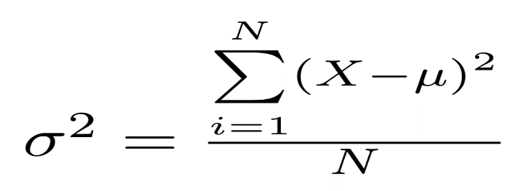

The Mean is x̄ = 3+21+98+203+17+9

6

= 58.5

Std. Dev = -55.5^2 + -37.5^2 + 39.5^2 + 144.5^2 + -41.5^2 + -49.5^2

6

= 3080.25 + 1406.25 + 1560.25 + 20880.25 + 1722.25 + 2450.25

6

= 31099.5

6

= 5183.25